**Extreme simple interface with no decoration.**

**Implemented:**

1. Two-way data binding (shown in username)
2. Receive data from user
3. Root and navigation ( glacier one and two)

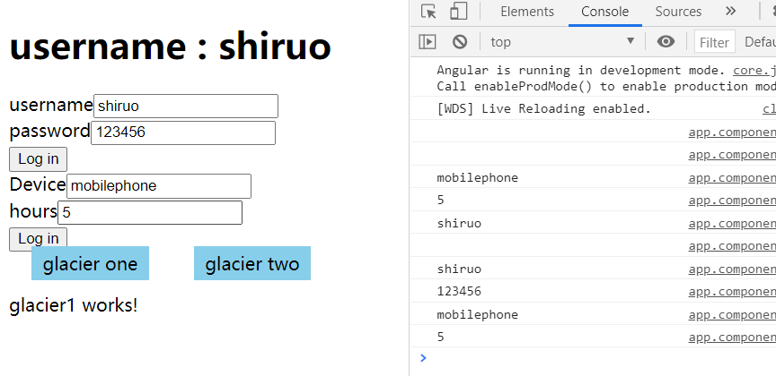

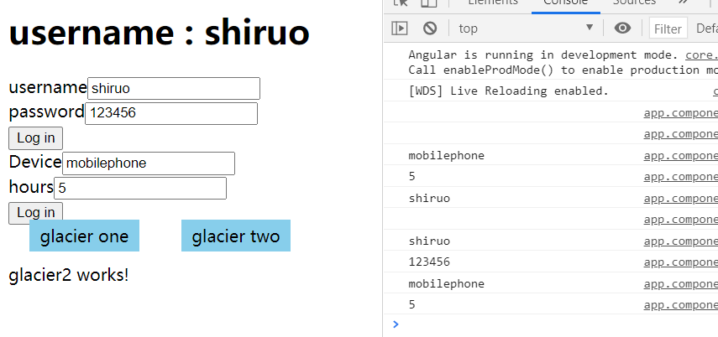

**To be done:**

1. server

tried to get access to another website using command” nodemon index.js”, but nodemon seemed not to work well. Tried to solve but failed.

Show different pics while clicking button” glacier one” or “ glacier two”—do help for glaciers showing in upcoming work.